October 11, 2021

Subject: Bid No. 9002.9 Door Hardware, Locks, Keys, Closures and Exit Devices

This is Amendment Number 2.

In accordance with the terms of the above-mentioned contract, this is authorization to extend this contract, through September 19, 2022. All terms and conditions remain the same.

Supplier(s):

Accredited Lock and Door Hardware, Co Independent Hardware, Inc.
1161 Paterson Plank Road 14 S. Front Street
Secaucus, NJ, 07094 Philadelphia, PA 19106

COMMENTS: Please see attached Summary of Contracts

REFER QUESTIONS TO: Anissa Black, Buyer, 301-279-3123

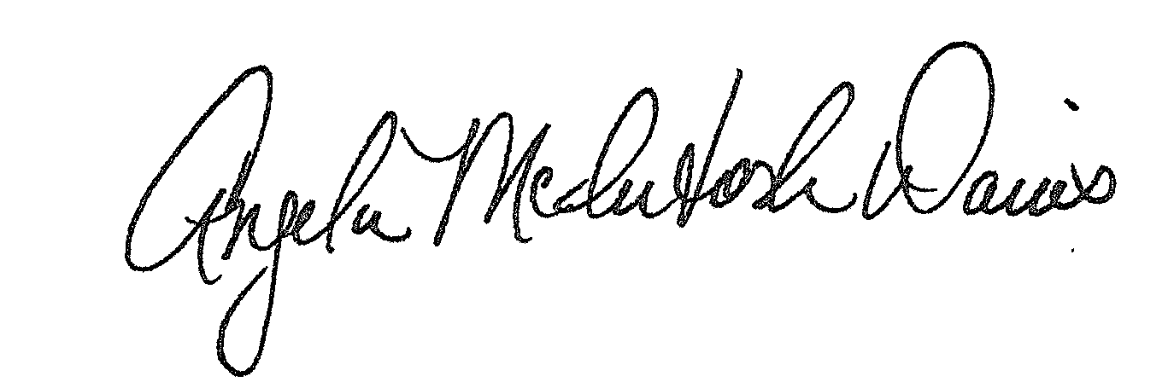

Approved:
Angela McIntosh-Davis, CPPB, Team Leader, Procurement Unit

AMD:abb
Distribution: Supplier(s); Bid File

